

**CTS Digital PRoDIGI 2022**

**Idea Demonstration Video Link -** <https://youtu.be/Kj8JIOVIy1s>

**Group Members**

Harsh Soni (20BCE10082)

Prakhar Raj Pandey (20BCE10423)

Gaurav Garwa (20BCE10530)

Aaditya Nayak (20BCE10950)

Shivansh Rastogi (20BCE11104)

**Contents**

* Problem Statement
* Background Work
* Proposed idea
* Approach
* Analysis of the Dataset
* How our idea delivers business value
* How is our idea unique
* How is our idea implementable
* How is our idea scalable
* Implementation in the MVP phase
* Technical Requirements
* Future Prospects
* References

**Problem Statement**

Supply chain event prediction and visibility: How can you provide visibility and predictive capabilities in the supply chain, in order to make the right decisions?

For Joe, the manager of a large apparel manufacturing company, it was essential that during peak demand seasons like Thanksgiving, Christmas, and New Year, he was able to have clear visibility into the supply chain to ensure that garments were delivered to retailers on time. He had to predict events that could cause bottlenecks and accordingly plan for mitigating the impact of such situations.

Some of the solutions Joe wanted were:

• Prediction of supply chain events using data from different sources, as inputs into planning.

• Analyzing impact on delivery time and availability of products due to supply chain events.

• Tracking goods movement as they leave the factory and reach the destination.

**Background Work**

We have studied the research papers and understood the steps involved in the supply chain (SC) management process, as shown below:

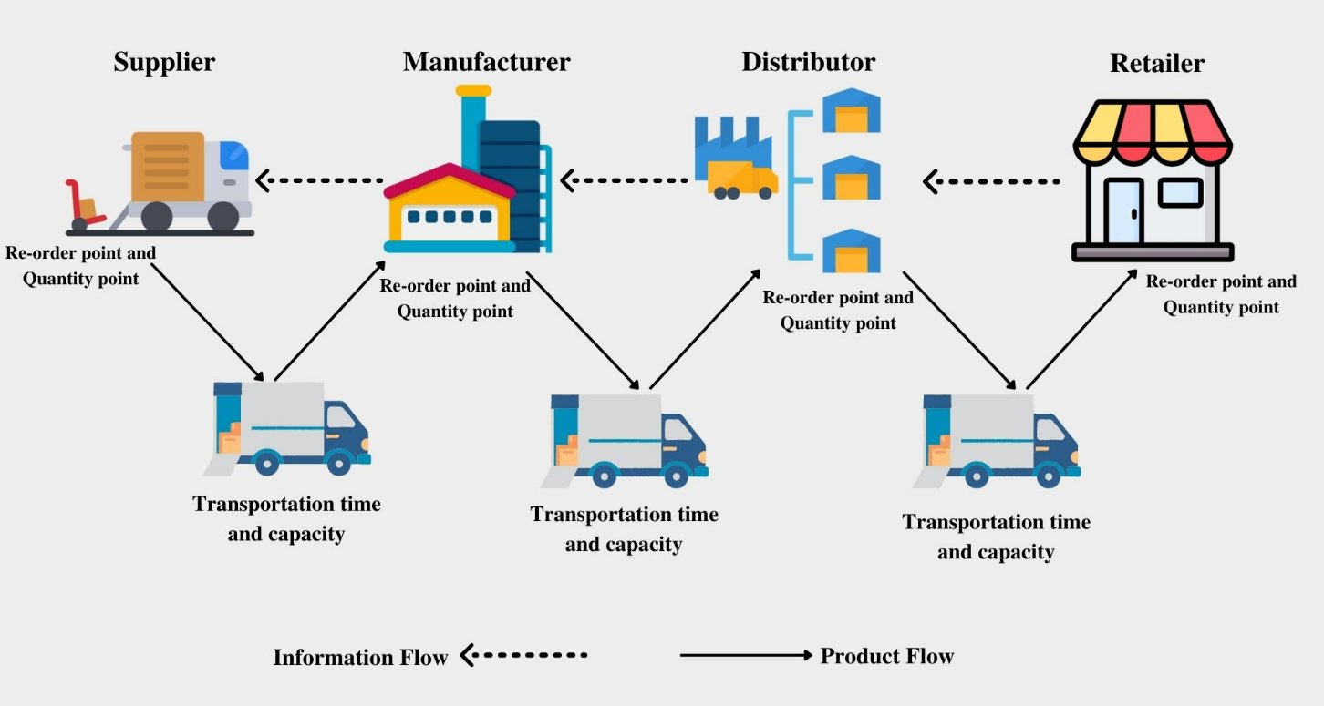

Here we can see the information and material flow between different phases. We will predict the product demand between retailer-distributor or distributor-producer or producer-supplier.

**Demand Signal -** A demand signal is a message issued within business operations or within a supply chain to notify a supplier that goods are required, and is, therefore, a key item of information for demand planners within a business.

Factors affecting supply chain performance

**• Supply chain structure -**

The number of facilities, the number of stages, and the structure of the material and information flow contribute to the complexity of the chain.

**• Inventory control policy -**

Inventory control means ensuring that the business has the right goods on hand to avoid stock-outs, prevent shrinkage, and provide proper accounting. There must be an economic balance between the costs incurred and the costs saved by holding the material in stock. The inventory control mechanism involves decisions regarding 'when' and 'how much to order.

**• Information Sharing -**

Information connects various SC partners and allows them to coordinate activities. Information is crucial to the daily operations at each stage of the SC. An information system can enable a firm to get a high variety of customized products to customers rapidly and to understand the changing customer's tastes and preferences.

**• Customer demand -**

Customer demand pattern is one of the environmental factors affecting the performance of the SC. In most industrial contexts, demand is uncertain and hard to forecast. When customer demand is wildly fluctuating, the member in an SC sends a highly variable order pattern to the associated member in the upper stage, which may cause amplification of order variance (which is termed as bullwhip effect) through the SC. Customer demand volatility also results in high capacity and inventory costs for the manufacturer.

**• Forecasting method -**

In a supply chain, the members need to forecast future demand, and it is impossible to predict demand with certainty. This uncertainty will result in distorted order quantity and via order variance amplification. The accuracy of the forecast highly influences the supply chain performance measures such as inventory cost, backorder cost, lost sales cost, and customer goodwill.

An inaccurate forecast results in the underutilization of the factory's capacity. It is identified as one of the main causes of the bullwhip effect in the supply chain is the use of demand forecasting.

**• Lead time -**

The time gap between the receipts of the order and to delivery of the product is referred to as lead time, which is the sum of the order lead time and delivery lead time

Under long lead time, the fluctuation in orders is more, which may result in a bullwhip effect.

**Sell-In / Sell-Out Model**

Sales can be divided into Sell In and Sell Out.

Sell In is the number of products the manufacturer sells to the retailer, while Sell Out is the number of products sold by the retailer to the end customers.

Retailers will not sell products if we do not supply them. Moreover, if they want to sell more because they are planning a promotion for our product, they also have to order more products from us.

**Proposed idea**

**Our detailed idea -**

We are trying to implement a machine learning model to examine the future statistics of any supply chain with the help of previous datasets.

The objective of this project is to perform a comparative analysis of forecasting the distorted demand signals in the extended supply chain using non-linear machine learning techniques. More specifically, the work focuses on forecasting the demand at the upstream end of the supply chain to avoid the bullwhip effect.

We will calculate/predict the approximate requirement that is going to be needed by the supplier(upstream) before the stock outage. So, the supplier can place orders in advance to minimize the assumed demand variability. Suppose a retailer wants to order any product from a wholesaler, then the model will accordingly calculate the quantity depending upon previous records considering peak demands like festive or sale seasons.

**How it will be implemented**

To do so we are going to need a dataset of any supply chain having entries like product-id, product category, date, warehouse and retailer location, price, quantity, etc.

Then we train the data using different ML models and find the most accurate one.

Some models are Linear regression, Neural Networks, Recurrent Neural Networks, Support Vector Machines, etc.

**Approach**

An accurate prediction for sales shortly can help managers to have a good plan for stocking, enhancing economic efficiency, and optimizing the business of the company.

Detecting accurate anomalies in sales enables the company to have an insight into its operating and marketing strategies. A negative anomaly in sales may correspond to not good strategies in marketing, leading to a decrease in sales. The strategies need to be reviewed and adjusted. By contrast, once a positive anomaly is detected from the model, it could be useful to investigate and explain the reason, thereby increasing sales and having appropriate strategies for the future.

We propose to solve the performance bottleneck in the SC on the Manufacturer's side by working on the following two aspects of the SC -

**• SC Forecasting -**

In this Part, we propose to work on the various traditional techniques of SC forecasting. And then extend our work towards using the new and current Industry leading Machine Learning based Methodologies of Forecasting.

We propose to provide a comprehensive Exploratory Data Analysis and Comparative Analysis of the above models.

• **Anomaly Detection in Sales and Demand Data -**

In this Part, we propose to use Machine Learning Techniques to build Anomaly Detection System over the Supply Chain data.

For SC Forecasting we will use the historical data from a manufacturing company that produces a variety of products and ships them to 4 warehouses.

The warehouses are placed in different locations all over the world Thus, it normally takes months to ship products to the warehouses.

This Dataset is perfect to analyse the Supply chain event in the upper part of the Supply Chain Model by establishing forecasting models that can predict the Events well in advance to give the manufacturer insight into the future demand signal.

A reasonably accurate forecast of the demand signal of the coming months will be highly beneficial for the Manufacturer.

The demand signal to the warehouse and the average Lead Time that scales to months show a strong correlation to the scenario that can be affected by the Bullwhip effect & other Factors that affect the Supply Chain Performance.

**Analysis of the Dataset**

* The first dataset will be collected from various archives which will be analyzed as Multivariate Time-series data for forecasting and the second one will be the generated datasets for detecting an anomaly
* The training data and validation data will be prepared and data from the training set will be fed to train the models. In the training process, the number of cells, dropouts, and the learning rate of the model will be optimized.
* Comparative analysis will be performed on various models from traditional techniques like VARMA, and ARIMA to the new LSTM model of Forecasting. This will help the client make decisions by providing historical trends in the company’s sales data.
* One-class support vector machine or OCSVM algorithm will be used to separate anomalies from the data output based on the LSTM Auto-encoder network.
* The LSTM Auto-encoder network and the OCSVM are trained based on the same training data set as for forecasting. Using a sliding window of size m, the trained auto-encoder LSTM can read the input sample, encode it and recreate it in the output with the help of which prediction error vector will be calculated.
* Since the dependency in the multivariate time series is eliminated by using the auto-encoder LSTM, the error vectors can be considered independent. From these vectors, the OCSVM can define a hyperplane to separate abnormal observations from normal samples.
* The output of the LSTM Auto-encoder reduced in a two-dimensional coordinate plane will be displayed. The characteristics extracted from anomaly data tend to be split into a cluster that will be different from the ones extracted from normal data. Then, the OCSVM can accurately classify anomalies from those representations and color them.
* The same model will provide insight into commodity shipping patterns and will help in understanding the bottlenecks in the existing architecture of the delivery system.

**How is our idea unique?**

* The complete chain is taken care of – the manufacturer - distributor – wholesaler – retailer – customer to find the anomaly in the supply chain accurately. (Extended supply chain model)
* In-depth research from various research papers is being reviewed to know various methods for making a robust supply chain predictive model.
* Comparative Analysis - Different predictive models are used to improve the accuracy and efficiency of the prediction model by analyzing the error rate in each model and then prioritizing them accordingly.
* The human perspective is also involved as the data is not completely dependent on factual data to minimize the possibility of error.
* Dataset parameters have been wisely chosen to ensure that most of the perspectives regarding the supply chain are being covered.
* The user will be able to get both monthly and annual predictions regarding supply and demand.
* Anomaly Detection - To detect anomalies or unexpected trends in sales, as an abrupt trend in demand is a major indicator of irregular data which can drastically impact the forecasting accuracy.

**How does our idea deliver business value?**

* Instead of relying just on one model, we are doing a comparative analysis to anticipate the distorted demand signals throughout the extended supply chain, resulting in outcomes that have the lowest error and maximum accuracy. Therefore, from a commercial standpoint, this will result in more precise demand and supply estimates, which lowers product time in the warehouses and assures continuous and efficient product flow between maker and retailer.
* Through supply chain forecasting the scheduling and planning process is vastly improved. Paying attention to the past and present demand for products allows a supply chain to stay on top of the game.
* Being able to anticipate and prepare for seasonal fluctuations in demand is only one of the many reasons supply chain management needs forecasting. In a similar vein, demand forecasting plays a significant role in and is crucial to preparing for promotional activities and new introductions. There is less uncertainty to worry about when projections are supported by facts. It results in the more effective use of time and enables you to effectively use seasonal and occasional needs.
* By definition, safety stock is the excess stock that is kept around as a safety net in case demand for a product increases. With forecasting, however, this extra measure is not needed. This frees up storage space and saves time and worry.
* Demand forecasting is crucial when it comes to JIT (Just In Time) systems and purchasing from suppliers with long lead times. In JIT systems, demand forecasting enables products to sit in storage for a shorter amount of time, resulting in less money being lost than if products were to occupy warehouse space for a prolonged period which leads to efficient use of storage.
* As typically, supply chain management relies heavily on monitoring, and from a business standpoint, tracking shipments is crucial. Our monitoring system's main goals are to maintain processes efficiently, ensure the security of shipments, and save money on gasoline and insurance.

**How is our idea unique?**

* The complete chain is taken care of – the manufacturer - distributor – wholesaler – retailer – customer to find the anomaly in the supply chain accurately. (**Extended supply chain model**)
* In-depth research from various research papers is being reviewed to know various methods for making a robust supply chain predictive model.
* **Comparative Analysis -** Different predictive models are used to improve the accuracy and efficiency of the prediction model by analyzing the error rate in each model and then prioritizing them accordingly.
* **Anomaly Detection -** To detect anomalies or unexpected trends in sales, as an abrupt trend in demand is a major indicator of irregular data which can drastically impact the forecasting accuracy.
* The human perspective is also involved as the data is not completely dependent on factual data to minimize the possibility of error.
* Dataset parameters have been wisely chosen to ensure that most of the perspectives regarding the supply chain are being covered.
* The user will be able to get both monthly and annual predictions regarding supply and demand.

**How is our idea implementable?**

* As mentioned in the first phase of our approach, we proposed to provide a comprehensive analysis using a variety of ML techniques to highlight the importance of the featured parameters and how they can prove to be beneficial as information to the client.
* The parameters are collected from various datasets and analyzed for their feasibility in supporting the hidden trends of the data.
  + Seasonality patterns
  + Sell in / sell out
  + Bullwhip
  + The effects of an anomaly in the data.
* We have outlined the issues in the problem statement and have matched them to the concepts introduced in the various existing types of research that are mentioned in the background work section.
* Thus, the following qualitative support from the data and concepts established in the background work is enough to prove that the proposed model can be implemented as a robust platform that can act as an aid to the client in making a better decision for the supply chain.
* Further better SC visibility can be achieved by establishing contracts between manufacturers and clients to share their sales data which will increase the quality of the data fed to the proposed model and ultimately increase the accuracy of the predictions.

**How is our idea scalable?**

If our product has the potential to add some value, even if it is a fraction of change, it will palpably become a large-scale application. Hence, we are looking forward to this change.

There is no doubt in saying that the world is full of supply and demand processes, everywhere, anytime something is going through any supply chain process, if our product has the potential to improve the supply chain even by a smaller fraction, big companies will adopt this because it will make a very large impact on a huge scale, like saving operations cost, managing the supply and demand seamlessly, avoiding bullwhip effect, etc.

We will be able to minimize the supply and demand fluctuation as described below:

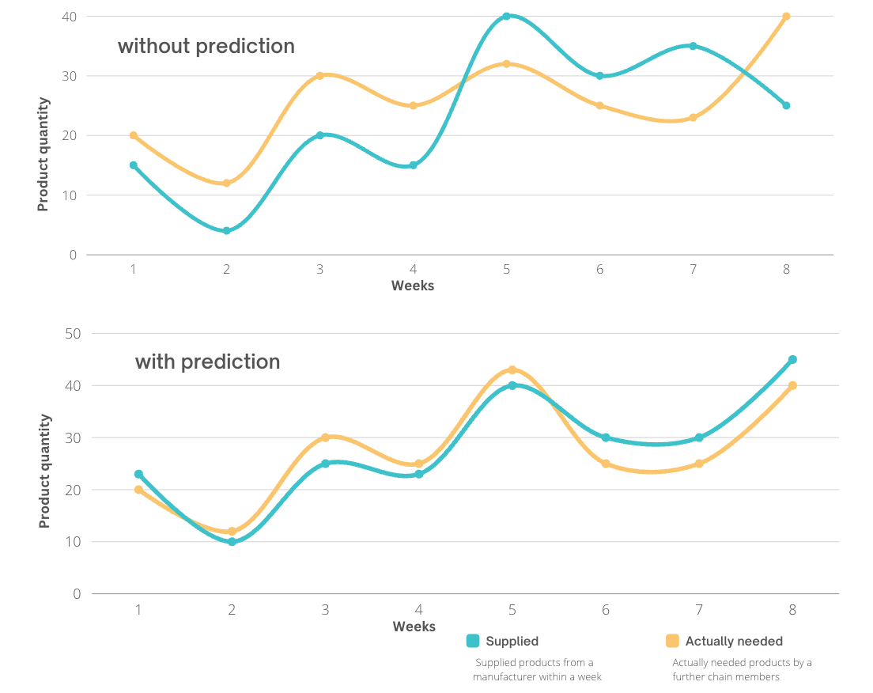

**Scalability factors we will work on:**

* **Solid Project Structure (Foundation) -** We will make the project efficiently functional, which allows users to navigate coherently which will make their business more profitable. Ex. simple UI, quick analysis, etc.
* **More data means a more effective product -** Analyse the data of wide spectrum circumstances (like peak demand seasons) to understand a vast SC structure that will help us to provide more streamlined output.
* **Studying the market -** Understanding user needs and updating the application accordingly, ex. if the market demands more data analytics, then we will provide that in our output.

**Implementation in the MVP phase**

* We will create new features based on the existing ones that enable machine learning algorithms to work. Getting the data right increases the quality of the data a lot because we transform the raw data into information that the model will transform into knowledge. Then the model can understand the pattern better and make better predictions.
* During the course of this project, we will perform a comparative analysis of various models of forecasting, from traditional techniques like VARMA and ARIMA to the new LSTM model, to improve accuracy and efficiency using the dataset provided by the manager based on our research for this project, which will be displayed on the web platform and android platform (Hybrid application). We will implement anomaly detection for quickly determining anomalies or unexpected patterns in sales, which will help the company gain insight into its operating and marketing strategies to make more effective decisions.
* Additionally, we will create a tracking system that will monitor and maintain the status of shipments from the producer to the merchant, resulting in a transparent and efficient flow of resources.

**Technical Requirements**

**Hardware requirements:**

* Processor: Minimum 1 GHz; Recommended 2GHz or more
* Hard Drive: Minimum 32 GB; Recommended 64 GB or more
* Memory (RAM): Minimum 2 GB; Recommended 4 GB or above
* Sound card w/speakers

**Software Requirements:**

* HTML
* CSS
* JavaScript
* React
* Flask
* Python
* Git & GitHub
* VS Code
* API
* JSON
* Figma

**Future Prospects**

* We can use M.L. to prioritize orders based on importance, which means looking at which orders will impact your business the most and ensuring that those are completed first. Focus on priority orders to increase revenue and reduce impact when all tasks might not be completed.
* We can use A.I. for demand forecasting. Using AI, organizations can make use of Machine Learning algorithms to predict changes in consumer demand as accurately as possible. These algorithms can automatically recognize patterns, identify complicated relationships in large datasets, and capture signals for demand fluctuation. (To implement machine learning in demand planning and forecasting, the ideal AI system is trained using data from different sources such as weather data, financial data, and third-party data e.g. social media, historical sales data, and macroeconomic data. The AI system makes predictions on how event combinations in the past affected demand for future consumer demand).

**References**

* Forecasting and Anomaly Detection approaches using LSTM and LSTM Autoencoder techniques with the applications in supply chain management HD Nguyen, KP Tran, S Thomassey, M Hamad - International Journal of Information Management, 2021
* Hau L. Lee, V. Padmanabhan, Seungjin Whang, (1997) Information Distortion in a Supply Chain: The Bullwhip Effect. Management Science 43(4):546-558
* Nathalie Silva, Luís Miguel D.F. Ferreira, Cristóvão Silva, Vanessa Magalhães, Pedro Neto, Improving Supply Chain Visibility With Artificial Neural Networks, Procedia Manufacturing, Volume 11, 2017
* Real Carbonneau, Kevin Laframboise, Rustam Vahidov, Application of machine learning techniques for supply chain demand forecasting, European Journal of Operational Research, Volume 184, Issue 3, 2008

**THANK YOU**